Scene Management Example

This is a simple example of multi-scene management. This example demonstrates **SceneRelationship** attribute extension for RapidIoC. The purpose of this extension is to avoid additional code to manually load/unload scenes and integrate scene loading with RapidIoC. For example, you may want to separate your HUD scene and your game scene. But your HUD scene should always be loaded when your game scene is loaded, so you could add **[SceneRelationship(typeof(HudSceneView), SceneRelationshipType.Include | SceneRelationshipType.Depend)]** to your game scene (see explanation below).

# How to run this example

1. Open **BuildSettings** (File->BuildSettings).
2. Add the following scenes to **Scenes in Build**:
   * RapidIoC/examples/SceneManagementExample/mainScene/MainScene.scene
   * RapidIoC/examples/SceneManagementExample/scene1/Scene1.scene
   * RapidIoC/examples/SceneManagementExample/scene2/Scene2.scene
   * RapidIoC/examples/SceneManagementExample/scene2Dependency/ Scene2Dependency.scene
   * RapidIoC/examples/SceneManagementExample/scene3/Scene3.scene
3. Your build settings should look something like this: 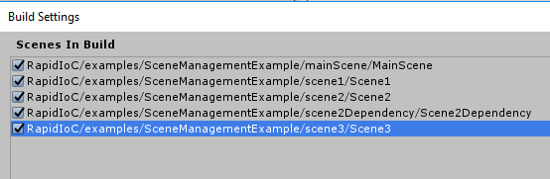
4. Load **MainScene** (RapidIoC/examples/SceneManagementExample/mainScene/MainScene.scene), this is your starting scene that sets up global bindings and loads your first actual game scene(s). (note: you should have only one **MainScene** loaded at any time). For example, your MainScene could load your MenuScene which would be the first actual scene with game logic.
5. Run the game.
6. Your game screen would look something like this:

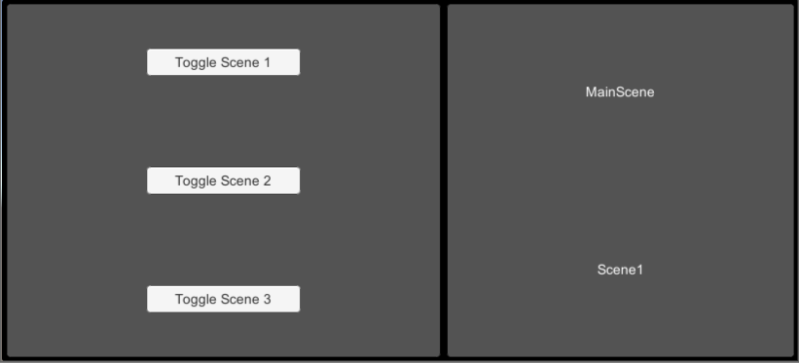

1. Buttons on the left panel load/unload scenes. Labels on the right panel show which scenes are currently loaded.
2. Each scene view (see Scene1, Scene2, etc.) creates a local context named after scene name (for more information on contexts see [Contexts and Bindings](https://github.com/cpgames/RapidIoC/wiki/Contexts-and-Bindings)).
3. Which scenes are loaded/unloaded is defined by **SceneRelationship** attribute appended for each **SceneView** class. For example, if you look at SceneView2 code:

|  |
| --- |
| namespace cpGames.core.RapidIoC.examples.sceneManagementExample  {  [SceneRelationship(typeof(Scene2DependencyView), SceneRelationshipType.Include | SceneRelationshipType.Depend)]  public class Scene2View : SceneView { }  } |
|  |

**[SceneRelationship(typeof(Scene2DependencyView), SceneRelationshipType.Include | SceneRelationshipType.Depend)]** translates to **Scene2DependencyView** will be loaded as soon as **Scene2** is loaded, and unloaded once **Scene2** is unloaded.

1. Full list of **SceneRelationship** attributes and what they do:
   * **Depend** – scene is unloaded once the parent scene is unloaded
   * **Include** – scene is loaded as soon as parent scene is.
   * **Exclude** – scene is unloaded as soon as parent scene is loaded.
2. **SceneView** can have multiple **SceneRelationship** attributes which also accept **Order** as an optional parameter, in case you want to load certain scenes before others.